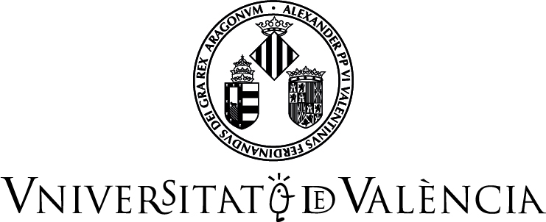 |  | 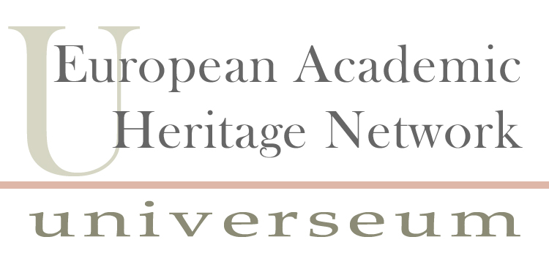

XIV UNIVERSEUM NETWORK MEETING
University heritage today: Beyond public engagement?
University of Valencia, Spain, 6–8 June 2013

Registration Form

First Name
Last Name
Job Title
Institution
Mailing Address
Postal Code
City
Country
Phone
Fax
Email

Have you submitted or plan to submit an abstract? YES NO

Vegetarian YES NO Other diet __________________________

Please complete and send the Registration Form to: Pedro.Ruiz-Castell@uv.es

